**APPENDIX 1**

PILLBOT: VOICE CONTROLLED ROBOT FOR DELIVERING MEDICINES

## A PROJECT REPORT

***Submitted by***

# HARINI V (2010105013)

**LAVANYA SRINIVASAN (2019105024)**

# JAYAASHREE P (2019105541)

**SHWETHA A (2019105576)**

***in partial fulfillment for the award of the degree of***

# BACHELOR OF ENGINEERING

***in***

## ELECTRONICS AND COMMUNICATION ENGINEERING



**COLLEGE OF ENGINEERING, GUINDY**

# ANNA UNIVERSITY::CHENNAI 600 025

DECEMBER 2022

**APPENDIX 2**



ANNA UNIVERSITY: CHENNAI 600 025

# BONAFIDE CERTIFICATE

Certified that this project report **“Pillbot: Voice controlled robot for delivering medicines”** is the bonafide work of **“Harini V, Lavanya S,**

**Jayaashree P and Shwetha A”** who carried out the project work under my supervision.

## SIGNATURE SIGNATURE

**Dr. M. Meenakshi Dr. Jeyalakshmi V**

## HEAD OF THE DEPARTMENT SUPERVISOR

Professor Professor

Department of ECE Department of ECE

College of Engineering, Guindy College of Engineering, Guindy

Anna University, Anna University,

Chennai-600025 Chennai-600025

## ACKNOWLEDGEMENT

First and foremost, we thank God for an abundance of grace and countless blessings in making this work a great success.

We also express our sincere gratitude to our HOD, Dr. M. MEENAKSHI, Professor, Department of Electronics & Communication Engineering for her enthusiastic encouragement and support throughout the project.

We are sincerely grateful and present our thanks to our project supervisor, Dr. Jeyalakshmi V, Assistant Professor, Department of Electronics and Communication Engineering for her whole hearted support, patience, valuable guidance, technical expertise and encouragement in our project.

We thank all the teaching and non-teaching staff of the Department of Electronics and Communication Engineering, for their kind help and co-operation during the course of our project.

Last but not the least; we would not have made this project without the support from our beloved family and friends.

We would also like to thank the Department for allowing us to use the facilities of the Electronic System Design and Fabrication Laboratory for PCB Designing.

# ABSTRACT

In this project, a system is proposed, which focuses on the concept of how a robot can be controlled by human voice. Voice control robot is just a practical example of controlling motions of a simple robot by giving daily used voice commands. In this system, an android app is used as a medium for the transmission of human commands to microcontroller. The controller can be interfaced with the Bluetooth module through the UART protocol. The speech is received by the android app and processed by the voice module. Voice is then converted to text. The microcontroller will further process this text, which will take suitable action to regulate the robot. Thus, a robotic car has been designed whose basic movements such as moving forward, turning to left or right can be controlled by the human voice. Then the same project was upgraded to navigate to different rooms in a hospital for the delivery of medicines. The Hardware Development board used here is the ATmega Arduino board. The software part is done in Arduino IDE using Embedded C. Hardware is implemented, and software porting is done. Generally, recognition of human voice using some kind of module costs way too much. After performing an ample amount of studies robot control, we came to the conclusion that an efficient way to manipulate robots through our voice is via the app created thus, through MIT APP inventor. This is an ergonomic approach for the ease of robotic application. Such types of robots will provide great helping hands while performing multiple tasks. And in this project, we have implemented it as a “PILLBOT” which delivers medicines to patients in different rooms of a hospital. The result of our studies also shows that there still exists plenty of space for further research and development.



இந்த திட்டத்தில் , ஒரு அமைப்பு முன் மைொழியப்பட்டF, இF ைனித குரல் மூலை் ஒரு ரரொரபொமை எை் ைொறு கட்டுப்படுத்தலொை் என் ற கருத்மத மையைொகக் மகொண் டF. தினசரி பயன் படுத்தப்படுை் குரல் கட்டமைகமை ைழங் குைதன் மூலை் ஒரு எைிய ரரொரபொவின் இயக்கங் கமைக் கட்டுப்படுத்Fைதற்கு குரல் கட்டுப்பொட்டு ரரொரபொ ஒரு நமடமுமற உதொரணை் . இந்த அமைப்பில் , ைனித கட்டமைகமை மைக்ரரொகண் ட்ரரொலருக்கு அFப்புைதற்கொன ஊடகைொக ஆண் ட்ரொய் டு பயன் பொடு பயன் படுத்தப்படுகிறF. கட்டுப்படுத்திமய UART மநறிமுமற

மூலை் புளூடூத் மதொகுதியுடன் இமணக்க முடியுை் . ரபசசு ஆண் ட்ரொய் டு

ஆப் மூலை் மபறப்பட்டு குரல் மதொகுதி மூலை் மசயலொக்கப்படுகிறF. குரல் பின் னர் உமரயொக ைொற்றப்படுகிறF. மைக்ரரொகண் ட்ரரொலர் இந்த உமரமய ரைலுை் மசயலொக்குை் , இF ரரொரபொமை ஒழுங் குபடுத்த தகுந்த நடைடிக்மக எடுக்குை் . எனரை, ஒரு ரரொரபொ கொர

ைடிைமைக்கப்பட்டுை்ைF, அதன் அடிப்பமட இயக்கங் கைொன

முன் ரனொக்கி நகரத்FைF, இடF அல் லF ைலF பக்கை் திருை் புைF

ரபொன் றைற்மற ைனித குரலொல் கட்டுப்படுத்த முடியுை் . பின் னர் அரத திட்டை் ைருந்Fகமை மடலிைரி மசய் ைதற்கொக ைருத்Fைைமனயில் மைை் ரைறு அமறகளுக்கு மசல் ல ரைை் படுத்தப்பட்டF. இங் கு பயன் படுத்தப்படுை் ைன் மபொருை் ரைை் பொட்டு ைொரியை் ATmega Arduino

ரபொரடு ஆகுை் . மைன் மபொருைின் பகுதி Arduino IDE இல

உட்மபொதிக்கப்பட்ட C. ைன் மபொருை் மசயல் படுத்தப்படுகிறF, ரைலுை் மைன் மபொருை் ரபொரடிங் மசய் யப்படுகிறF. மபொFைொக, சில ைமகயொன மதொகுதிகமைப் பயன் படுத்தி ைனிதக் குரமல அங் கீகரிப்பF மிகவுை் அதிகைொக மசலைொகுை் . ஏரொைைொன ஆய் வுகை் ரரொரபொ கட்டுப்பொட்மடச் மசய் த பிறகு, MIT APP கண் டுபிடிப்பொைர் மூலை் உருைொக்கப்பட்ட பயன் பொட்டின் மூலை் எங் கை் குரல் மூலை் ரரொரபொக்கமைக் மகயொளுைதற்கொன ஒரு திறமையொன ைழி என் ற முடிவுக்கு ைந்ரதொை் . இF ரரொரபொட் பயன் பொட்டின் எைிமைக்கொன

பணிசசூழலியல் அணுகுமுமறயொகுை் . இத்தமகய ரரொரபொக்கை் பல

பணிகமைச் மசய் யுை் ரபொF மபருை் உதவிகரைொக இருக்குை் . இந்த திட்டத்தில் , ைருத்Fைைமனயின் மைை் ரைறு அமறகைில் உை்ை ரநொயொைிகளுக்கு ைருந்Fகமை ைழங் குை் "பில் பொட்" ஆக மசயல் படுத்தியுை் ரைொை் . எங் கை் ஆய் வுகைின் முடிவு ரைலுை்

ஆரொய் சசி ைறறு் ை் ரைை் பொட்டிறகு் இன் Fை் நிமறய இடை் உை்ைF

என் பமதக் கொட்டுகிறF.

# TABLE OF CONTENTS

| **CHAPTER NO.** | **TITLE** | **PAGE NO.** |
| --- | --- | --- |
|  | **ABSTRACT(ENGLISH)** | 4 |
|  | **ABSTRACT(TAMIL)** | 5 |
|  | **LIST OF FIGURES** | 8 |
| **1** | **INTRODUCTION**   * 1. Motivation   2. Software requirement   3. Software overview |  |
|  | 9 |
| **2** | **LITERATURE SURVEY**   * 1. Voice controlled robotic vehicle   2. Android controlled arduino based voice controlled bot | 12 |
| **3** | 2.3 Voice controlling robotic vehicle by Bluetooth module  **APP CREATION AND BOT ASSEMBLY**   * 1. Design of Android app   2. Chassis Assembly for Robot   3. Integrating the designed robot with Arduino UNO via coding and the results obtained | 14 |

4.3 Drilling and soldering

# LIST OF FIGURES

| **FIGURE NO.** | **TITLE** | **PAGE NO** |
| --- | --- | --- |
| 3.1.1 | UI design of the app | 14 |
| 3.1.2 | Block placement for app creation | 15 |
| 3.1.3 | Working of app | 15 |
| 3.2.1 | Chassis kit | 16 |
| 3.2.2 | Robotic assembly using chassis kit | 17 |
| 4.1.1 | EASY EDA circuit layout | 20 |
| 4.1.2 | Routing | 21 |
| 4.1.3 | Final exported PNG file | 21 |
| 4.2.1 | Various PCB fabrication techniques | 22 |
| 4.2.2 | Laser etched board | 23 |
| 4.2.3 | IPG LASER machine | 23 |
| 4.3.1 | Drilled board- both sides | 24 |
| 4.3.2 | Soldered PCB front and back | 26 |
| 5.1.1 | Blocks in MIT app inventor | 27 |
| 5.1.2 | Interface design for modified app | 28 |
| 5.2.1 | Layout | 29 |
| 5.2.2 | New bot | 29 |
| 5.3.1 | Bot movement room 1 | 30 |
| 5.3.2 | Bot movement room 2 | 30 |
| 5.3.3 | Bot movement room 3 | 31 |

## CHAPTER 1 INTRODUCTION

* 1. **MOTIVATION**

The main motivation for this work comes from the fact that a lot of healthcare workers got affected severely during the novel corona virus outbreak that spread into a worldwide pandemic which shook the world due to its extremely high virulence and spreading factor. Better and safer delivery of food and medicines to isolated and quarantined patients could have reduced the impact of the disease on the healthcare personnel, thereby providing a safer hospital/quarantine environment.

Thus, in view of the safety and medical concerns of patients and the persons delivering medicines on a timely fashion, delivery of medicines in wards of hospitals using robotic machines/cars is extremely essential. The robot designed in this project traverses the wards where the medicine needs to be delivered using an intelligence-based algorithm working with the help of sensors and indicators marked in the wards. The bot would ensure that it does not collide with other robots and humans in the path and also would search for the indicator where the medicine would have to be delivered on a timely fashion. This way, we can ensure that contagious diseases are not transferred when medicine delivery is done and also compared to the same with laborious process being done manually. This proposed method’s functionality and algorithm was tested on a prototype arena and was proven to be successful using the prototype robot. The proposed method saves time and also human resources and is easy to operate with external monitoring from the hospital reception.

## SOFTWARE REQUIREMENT

* + - MIT APP INVENTOR
    - ARDUINO IDE
    - EASYEDA

## SOFTWARE OVERVIEW

* + 1. **MIT APP INVENTOR**

MIT App Inventor is a web application integrated development environment originally provided by Google, and now maintained by the Massachusetts Institute of Technology (MIT). It allows newcomers to computer programming to create application software (apps) for two operating systems (OS): Android, and iOS. It is free and open-source software released under dual licensing.

It uses a graphical user interface (GUI) very similar to the programming languages Scratch (programming language) and the StarLogo, which allows users to drag and drop visual objects to create an application that can run on Android devices, while an App-Inventor Companion (the program that allows the app to run and debug on) that works on iOS running devices are still under development.

App Inventor and the other projects are based on and informed by constructionist learning theories, which emphasize that programming can be a vehicle for engaging powerful ideas through active learning.

App Inventor also supports the use of cloud data via an experimental Firebase Realtime Database component.

## ARDUINO IDE

The Arduino Integrated Development Environment - or Arduino Software (IDE) - contains a text editor for writing code, a message area, a text console, a toolbar with buttons for common functions and a series of menus. It connects to the Arduino hardware to upload programs and communicate with them.

Programs written using Arduino Software (IDE) are called sketches. These sketches are written in the text editor and are saved with the file extension .ino. The editor has features for cutting/pasting and for searching/replacing text. The message area gives feedback while saving and exporting and also displays errors. The console displays text output by the Arduino Software (IDE), including complete error messages and other information. The bottom righthand corner of the window displays the configured board and serial port. The toolbar buttons allow you to verify and upload programs, create, open, and save sketches, and open the serial monitor.

## EASYEDA

EasyEDA is a web-based EDA tool suite that enables hardware engineers to design, simulate, share - publicly and privately - and discuss schematics, situations and PCB. Other features include the creation of a bill of materials, Gerber files and pick and place files and documentary outputs in PDF, PNG and SVG formats.

EasyEDA allows the creation and editing of schematic diagrams, SPICE simulation of mixed analogue and digital circuits and the creation and editing of printed circuit board layouts and, optionally, the manufacture of printed circuit boards.

Import from Altium Design, CiruitMaker, Eagle, Kicad and LTspice file formats as well as generic SPICE netlists is supported. SPICE netlists can be exported to third party simulation tools and export of PCB netlists in Altium, PADS and FreePCB formats is also supported.

The ability to import LTSpice schematics and symbols provides a useful way to port schematics to PCB layout without having to redraw them from scratch.

Once Gerber files of a completed PCB design have been downloaded and checked - using a third party Gerber viewer - the user is free to choose a PCB manufacturer or, for a fee, they can submit the Gerbers directly to EasyEDA for manufacture. Alternatively, printable PCB layer image output is also supported in PDF, PNG and SVG formats for home PCB etching.

The tool also includes sharing and collaboration features and a comprehensive parts and an expanding SPICE model library.

## CHAPTER 2 LITERATURE SURVEY

* 1. **Voice Controlled Robotic Vehicle**

*Dipesh Diwakar, Ashok Choudhary, Ashu Singh, Prof Nazish Fatima (2019)*

In the project presented in this paper, voice commands to the robotic system are sent through Bluetooth via an Android device. These commands are received on the robotic system via Bluetooth module mounted on it. A robotic arm is mounted at the front of the system to make changes in the environment along with an lcd screen to view the received commands. The motor driver circuit is used to control the speed of robotic system. An obstacle detector is added to protect the system from object on the way by using an ultrasonic sensor. The whole circuitry is powered using a 12V rechargeable battery mounted on the system. Here, Speech Recognition i.e., making the system to understand human voice is used. Speech Recognition is a technology where the system understands the words not its meaning given through speech. Speech is an ideal method for robotic control and communication. The purpose of the research paper is to provide simpler robot’s hardware architecture but with powerful computational platforms so that robot’s designer can focus on their research and tests instead of Bluetooth connection infrastructure. This simple architecture is also useful for educational robotics, that students can build with low cost.

## Result and conclusion derived from the paper:

The voice controlling commands were successfully transmitted via Bluetooth technology and on reception; the desired operations successfully took place. This project reduced human efforts at places or situations where human interventions are difficult. Such systems can be brought into use at places such as industries, military and defense, research purposes, etc.

## Android controlled Arduino based voice controlled bot

*Archana Ashok Gajare, Amruta Anil Chandawale, Priyanka Dhanaji Agalave, Pallavi Prabhakar Gurav, Tejaswini Ravindra Patil (2021)*

Smartphones are one of the most essential things for human life in the 21st century. The Arduino voice-controlled robot interface with the Bluetooth module HC-05. We can give specific voice commands to the robot through the Android app installed on the phone. The Bluetooth transceiving module on the receiving side receives

commands and sends them to Arduino, thus controlling the robot. The aim of this project was to control the speed of a simple robot by giving voice commands that are used every day. The bot moves in the forward, reverse, left and right directions.

In this architecture, there are two sections i.e., Transmitter section and Receiver section. In transmitter section, Android app on the smartphone connected to the phone Bluetooth. Next in receiver section, HC-06 Bluetooth is linked to the Arduino board. The Arduino board receives voice command from Bluetooth HC-06. The Arduino Board is linked to the L293D Motor Driver IC. And L293D Motor Driver IC link to the left and right DC motors.

## Voice Controlling Robotic Vehicle by Bluetooth Module

*R. Rajalakshmi, Y. Sushma, T. Sowmya (2021)*

An ARM series microcontroller which is inter connected with the Aurdino. And this Robotic car is connected to mobile App like AMR-voice, etc., which makes the robotic vehicle to move after getting the commend from the user. The android mobile Application is connected with the Bluetooth module which is on the receiver side. The order is sent to the robot utilizing voice orders present on the android application. The speech (or) voice commands are received by a microphone which is present in the smart phone are processed by the voice module. When the voice signal commands are given to the Mobile Application, the VR module which is present in the mobile gets voice commands signals and convert the voice analog voice command signals to digital signals. Further, the digital signals are sent Bluetooth which is present on the receiver side. The Bluetooth on the robot side will receive the signals and the Arduino performs the loop execution and the motor driver which is made up with the motor connections will control the rotation of motors according to the commands given by the user.

# CHAPTER 3

**APP CREATION AND BOT ASSEMBLY**

## DESIGN OF ANDROID APP:

MIT APP inventor is first used to design the basic voice controlling app that would dictate the movements of the robot.

* + - Once, we open the MIT APP inventor, we first design the User Interface of the app to be created.
    - This is done as shown in figure 3.1.1.
    - In the app interface, a Bluetooth connectivity button was placed given the proper dimension specifications
    - A button for voice recognition was also placed, which on being clicked uses the ‘Google voice’ functionality to convert voice to text.
    - The converted text is then displayed for user verification as shown in figure 3.1.3

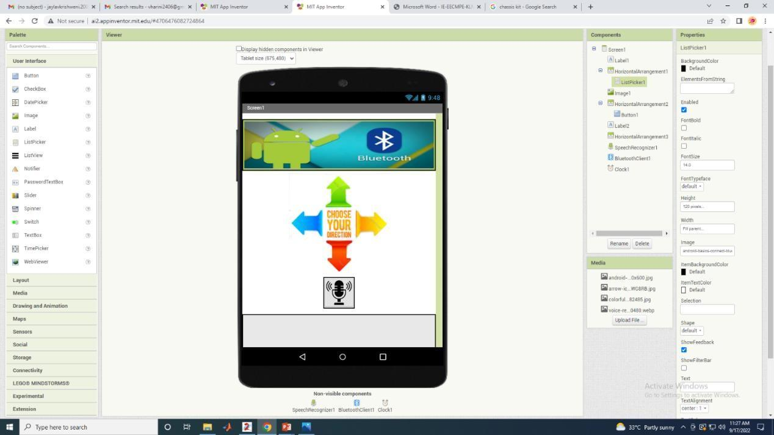

| **4** | **PCB FABRICATION**   * 1. Design of circuit in EASY EDA   2. PCB fabrication | 19 |
| --- | --- | --- |
| **5** | **FINAL PILLBOT ASSEMBLY AND CONCLUSION**   * 1. Modifications to app   2. Robot assembly modifications | 27 |
| **6** | 5.3 Final working and conclusion  **References** | 32 |

Fig. 3.1.1 UI design of the app

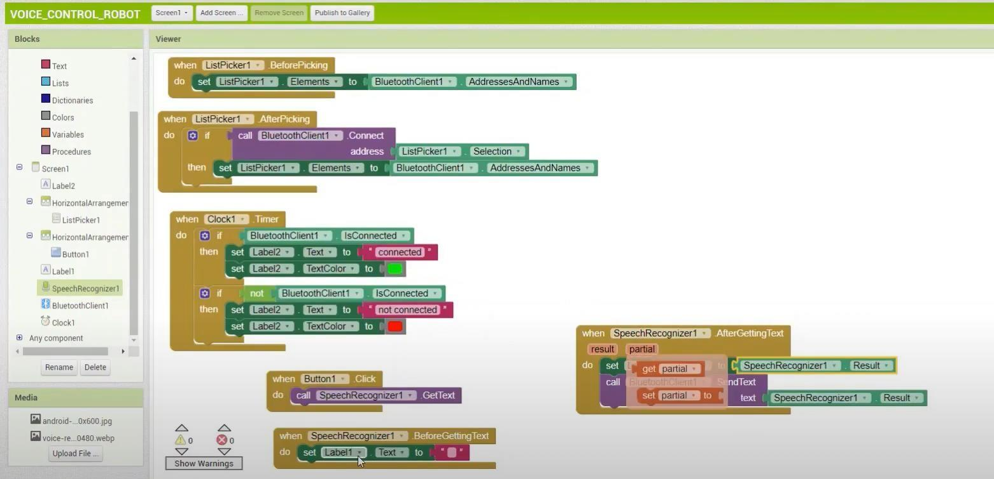

Fig.3.1.2 Block placement for App creation

* + - Once the UI is designed, blocks are picked and placed according to the functionalities of the app as shown in figure 3.1.2
    - Blocks for Bluetooth connectivity: “BluetoothClient1” >> “AddressesAndNames” are placed.
    - Similarly blocks for speech recognition: “SpeechRecognizer1” >> “GetText”, if button is pressed.
    - This way app is designed
    - The app is then built on the browser online, and the generated QR code is then scanned in the mobile phone to download it.
    - The downloaded app can be used to control the bot by issuing voice commands.

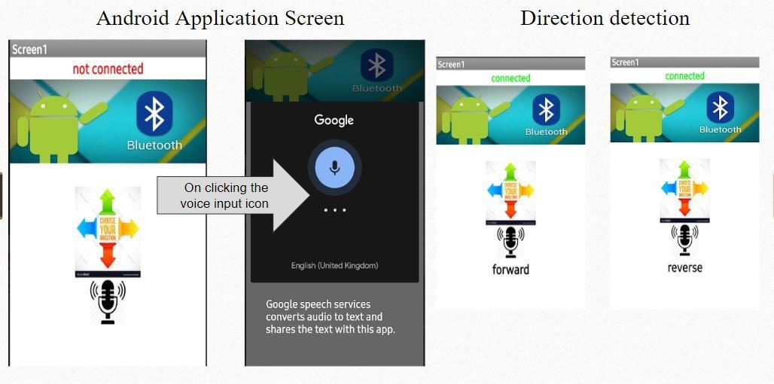

Fig.3.1.3 Working of app

## CHASSIS ASSEMBLY FOR ROBOT

This chassis has multiple holes and slots so that you can fit your electronics easily on this rigid chassis. It is made from 3 mm acrylic sheet. holes and standoffs are compatible with Arduino compatible boards so it can be easily mounted on top. Chassis size is 110 x 125mm.

## Features:

* + - Made from Laser cut 3mm Acrylic Sheet
    - Multiple slots for mounting extra electronics easily
    - Compatible with Ultrasonic distance sensor

Figure 3.2.1 Chassis kit

* + - Arduino compatible boards can be mounted inside as well as on top.

## In this stage, the chassis is assembled as shown in the figure 3.2.1.

The steps involved in chassis assembly are enlisted:

* Insert the coded discs to the sides of each of the two gear motors
* Attach these then to the acrylic car floor via acrylic fasteners using nuts and screws
* Next make the circuit connections to the L293D motor driver and fit it perfectly above the Arduino UNO.
* Interface the Bluetooth module HC05 with the system through a breadboard.
* A power bank is connected to the Arduino for supply.
* Once the connections are made as shown, the chassis is ready and the bot is perfect for voice control.

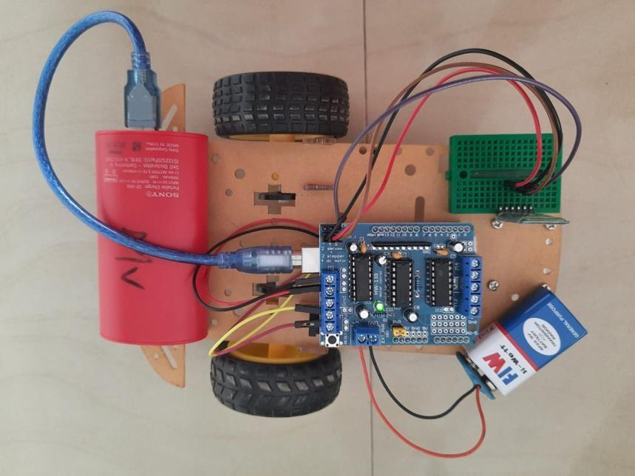

Fig.3.2.2 Robot assembly using chassis kit

## INTEGRATING THE DESIGNED ROBOT WITH ARDUINO UNO VIA CODING AND RESULTS OBTAINED:

The app that has been designed and downloaded is now used control the movement of the prototype bot.

This is done by using the Arduino microcontroller through Bluetooth. Bluetooth technology exchanges data over a short range but is very proficient way of communicating between two devices such as microcontroller and a smartphone.

The input voice commands given to the app are transferred via Bluetooth to the Arduino. Once the command has been received, the Arduino then compares the text to the pre-programmed instructions.

Voice commands like: ‘FORWARD’, ‘REVERSE’, ‘LEFT’, ‘RIGHT’ and ‘STOP’ are detected by Arduino which then maps these instructions into suitable commands to navigate the Bot in the said direction. This is achieved by programming the microcontroller.

Once the wheels of the robot receives the instruction from Arduino, it moves accordingly, thereby causing robotic movement as desired by the user.

# CHAPTER 4 PCB FABRICATION

This chapter discusses the various steps involved in PCB design, fabrication and incorporation into the PILLBOT application.

This includes designing the circuit, fabrication, drilling and finally, soldering the drilled holes with header pins as desired.

## DESIGN OF CIRCUIT IN EASY EDA

As presented in section 1.1.3, EasyEDA is a web-based EDA tool suite that enables hardware engineers to design, simulate, share - publicly and privately - and discuss schematics, situations and PCB.

In this project, we designed the entire circuit as discussed above in the form of a PCB for a better and more efficient working of the robot.

* + - Open a new schematic, and place the components: Arduino UNO, L293D IC.
    - Use 2 PIN RMC for the supply (pins: supply, ground)
    - Use 4 PIN RMC for the Bluetooth (pins: supply, ground, rxtx, txrx)
    - Use 4 PIN RMC for the Motor connections (pins: motorwire1, motorwire2, motorwire3, motorwire4)
    - Now make connections between the Arduino and L293D as shown in figure 4.1.1
    - Verify the connections and names for every port before routing.
    - After circuit designing, routing is done. Figure. 4.1.2
    - Automatic routing was used for faster execution.
    - Automatic routing, however, was manually changed for several connections for a neater finish and for a better use of space in the designed PCB.
    - Board outline was then set as:

START X: 38.227 mm; START Y: 26.289 mm WIDTH: 68.58 mm; HEIGHT: 56.904 mm

* + - The routed model is exported as PNG image (bottom layer)
    - The PNG file can then be used for LASER engraving on the board. Figure 4.1.3

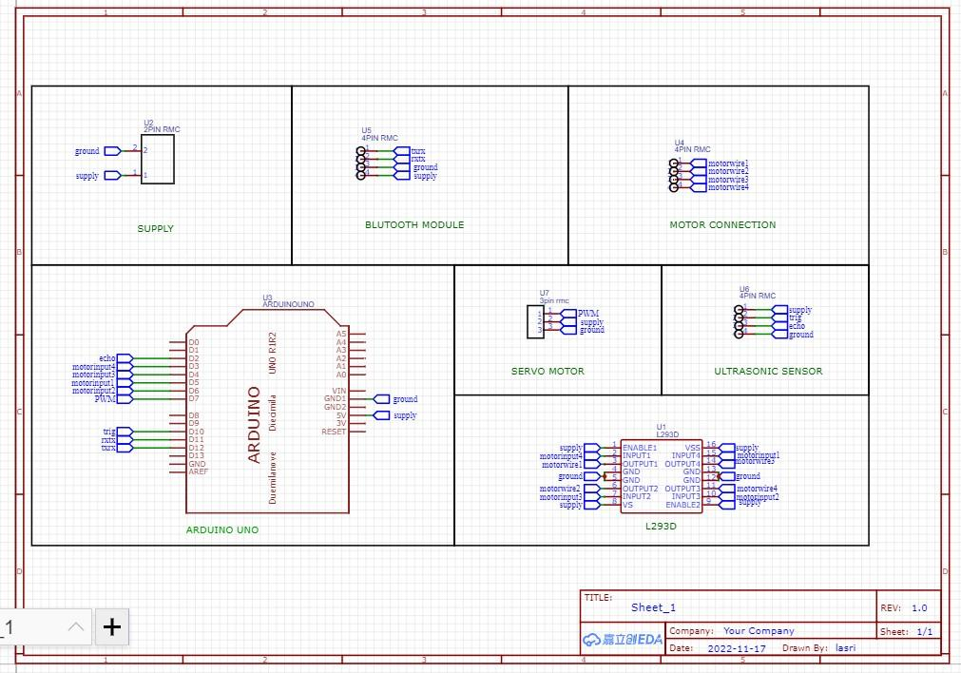

Fig. 4.1.1 EASY EDA circuit layout

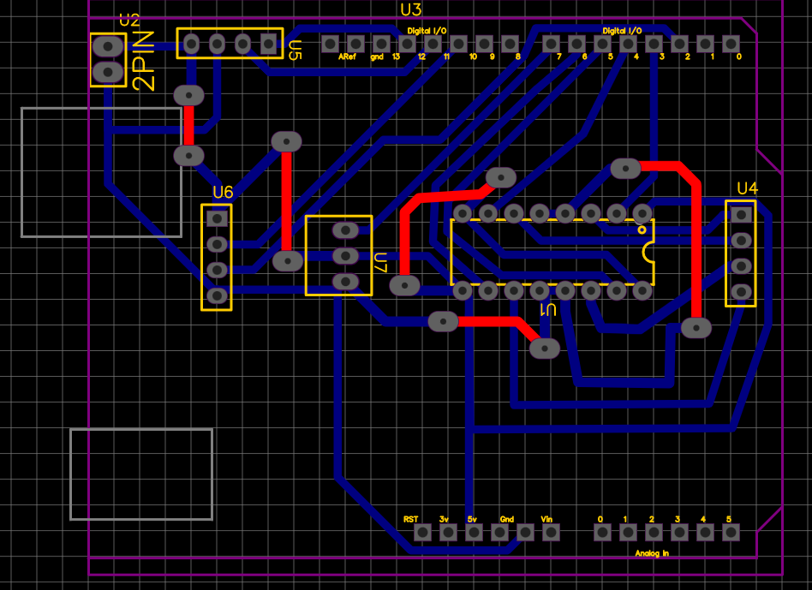

Fig. 4.1.2 Routing

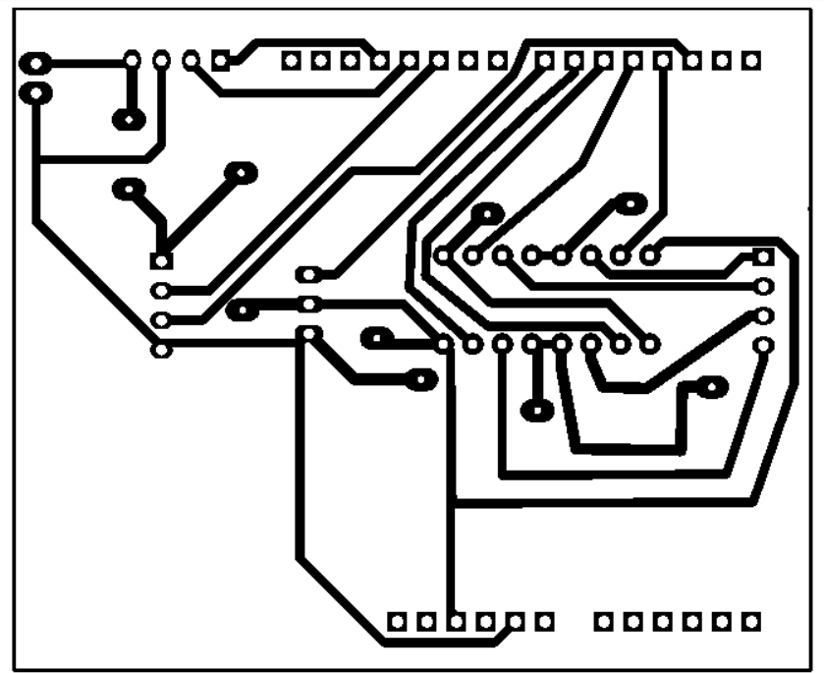

Fig. 4.1.3 Final exported PNG file

## PCB FABRICATION

There are several techniques for PCB fabrications as shown in figure 4.2.1.

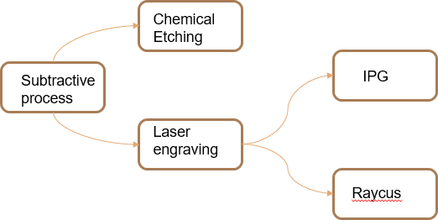

Fig. 4.2.1 Various PCB fabrication techniques

PCB can be either fabricated through chemical etching or via laser engraving.

For this project, Laser engraving was chosen as it is more precise and doesn’t require further finishing techniques like using FeCl3 solution for chemical etching after printing component design.

## 4.2.1 LASER ENGRAVING

Laser engraving is a process that vaporizes materials into fumes to engrave permanent, deep marks. The laser beam acts as a chisel, incising marks by removing layers from the surface of the material. The laser hits localized areas with massive levels of energy to generate the high heat required for vaporization. Laser engraving sublimates the material surface to create deep crevices. This means that the surface instantly absorbs enough energy to change from solid to gas without ever becoming a liquid. To achieve sublimation, the laser engraving system must generate enough energy to allow the material’s surface to reach its vaporization temperature within milliseconds.

* Laser etching was done five times in both X and Y directions using IPG laser machine shown in figure 4.2.3.
* The laser etched board is shown in figure 4.2.2

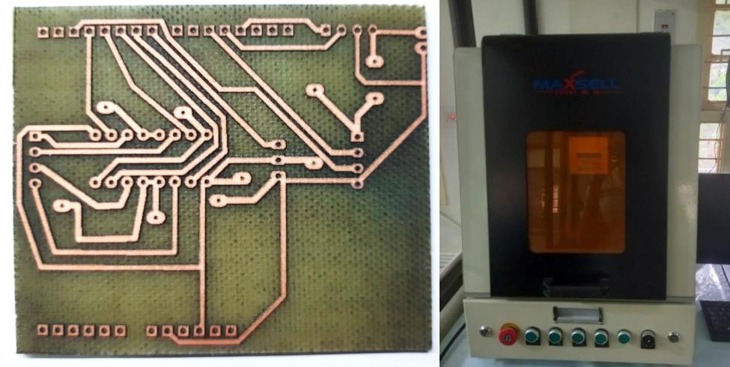

Figure 4.2.2 Laser etched board Figure 4.2.3 IPG Laser machine

## DRILLING AND SOLDERING

PCB drilling (which is also known as printed circuit board drilling), is the process of creating holes, slots and other cavities in an electronic circuit board.

During the PCB drilling process, a number of different hole types are drilled. These include via holes (such as thru-holes, buried holes, blind holes and micro-holes), component holes and mechanical holes.

Due to the precision required, holes are usually carved out using a manual or laser PCB drill. Boards can also be fed into a drilling rig manually or automatically.

Drilling is the most expensive and time-consuming part of the circuit board manufacturing process because the process must be carried out precisely to ensure the highest possible levels of quality.

We used WEN manual drilling machine to drill holes into the board.

The first step before any drilling is performed is to drill a pilot hole. This is used to keep the drill bit from “walking,” which means the bit starts in one location and moves towards an unintended direction while drilling. It can be done by hand using a small drill bit or can be done with an automatic tool called a drill press.

The next step is to choose an appropriate drill bit. It is very important to make sure the drill bit you use for your PCBs is the right size. If the bit is too big, it can damage the components in your circuit board drill. On the other hand, if it is too small, the wires will not pass through the holes drilled.

**The size of the drill bit used for this purpose is 0.8 mm.**

Drilling holes in a circuit board can be challenging if you don’t have the right tools and materials. It is important to take your time and be patient when drilling holes because rushing through the process can cause damage to the board. When drilling, always ensure that your drill bit is not spinning too fast or too slow. It is also **important to use goggles** while drilling so that you don’t damage your eyesight.

Once you are finished drilling your board, you must clean the holes with a brush and solvent. The solvents will remove any metal shavings that may have been created during drilling holes in PCBs. This will ensure that your board is ready for use when you are finished.

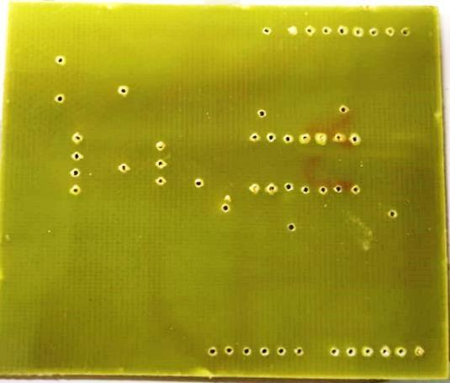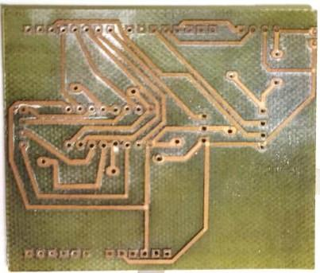

## Figure 4.3.1 Drilled board- both sides

Once drilling is complete, soldering is the next step. Although soldering has been the method of connecting wire components for very many years, it is still the method that is used as the standard way of making connections in electronics equipment.

Soldering is very simple in its conception, but despite this it is still very effective and can make good reliable electrical joints provided that the soldering has been done well in the first instance.

**Tools needed:** Obviously the first requirement is for a good soldering iron. Additionally, a small pair of pliers, possible a pair of small, round nosed pliers, a pair of small wire cutters and a few other tools may be needed.

Soldering preparation:

* Makes sure surfaces are clean
* Remove surface oxidation
* Clean connector bodies

Making the soldered joints:

* Place the components / wires to be soldered: The first step is to ensure that the components can either be moved into place easily, or they are already in place. This may involve placing the leads through holes in a printed circuit board, or securing them round a post.
* Clean the soldering iron bit: Next clean the bit of the soldering iron on the sponge and ensure there is a little solder on the bit. This also helps heat flow from the iron to the joint. Take the iron to the joint and apply the iron to the joint at the same time as the solder. Melt just enough solder onto the joint.
* Solder the joint: Apply the soldering iron and the solder to the joint simultaneously. Allow the solder to flow across it and for the flux to work. Allow enough solder onto the joint to make a good joint, but not excessive amounts - there should be no blobs of solder around! If the iron is held on the joint too long then the solder will oxidise and this will result in a dry joint.
* Remove the iron and wait for it to cool

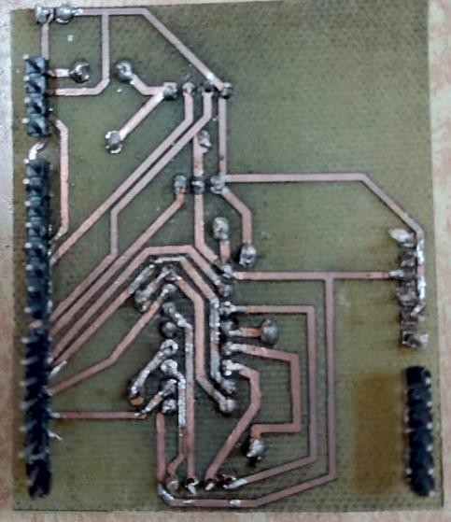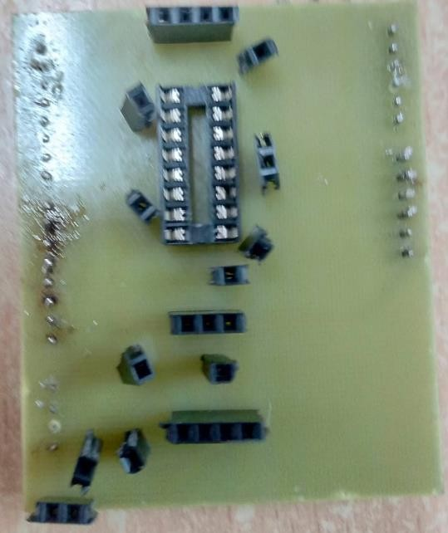

FIGURE 4.3.2 Soldered PCB front and back sides

# CHAPTER 5

**FINAL PILLBOT ASSEMBLY AND CONCLUSION**

This chapter discusses the final leg of the project, namely, the final modifications made to the initial voice-controlled prototype in order to enable it function as a “PILLBOT” or a voice-controlled bot for the delivery of medicines to various rooms in a hospital.

## MODIFICATIONS TO APP

The previously designed app takes in voice command in the form of directions. However, for this application, it is highly essential to design a robot that would move to different rooms for medicine delivery.

Thus, the app was modified in this stage to accept voice commands like: “ROOM 1”, “ROOM 2” and “ROOM 3”.

The app interface was also modified to accept the input through manual clicks via ‘buttons’ apart from the voice commands as an added feature.

This is depicted in figures 5.1.1 and 5.1.2.

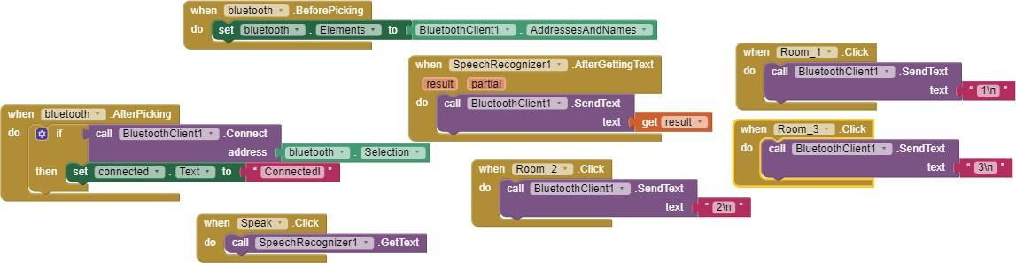

Figure 5.1.1 Blocks in MIT APP inventor

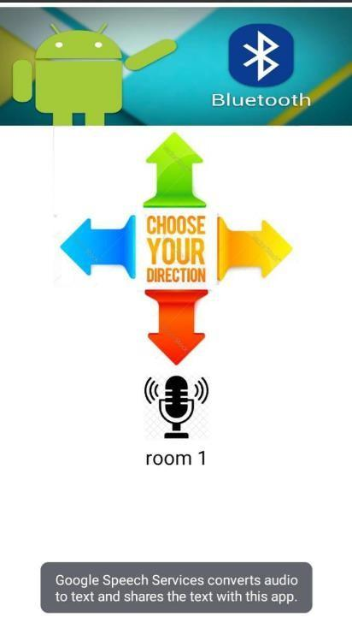

Figure 5.1.2 Interface design for the modified app

## ROBOT ASSEMBLY MODIFICATIONS

As aforementioned, it is necessary for the bot to move into different rooms in order to deliver food or medicines.

This calls for small modifications in the Robotic design.

For the navigation of the robot into various hospital rooms, it was proposed to use three different IR sensors that would help in tracing the path drawn on the ground and into the different quarantined rooms.

A prototype of this was designed using two charts, with the path marked with the help of black insulation tape.

This is shown in figure 5.2.1.

The new bot, thus assembled is shown in figure 5.2.2. It is seen that a basket has also been attached for the placement of tablets/medicines.



As depicted, the black lines are detected by the IR sensors present in the robot which helps the robot to move only in that particular direction and not anywhere else.

## 5.2.FINAL WORKING AND CONCLUSION

After all the updations, the working of the robot is verified by uploading

the code into the Arduino board and issuing commands through the App created.

It is observed that when “Room 1” command is given, the bot traverses the route as drawn on the chart for room 1 as shown in figure 5.3.1

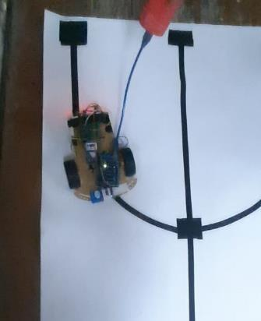

Figure 5.3.1 Bot movement to room 1

It is observed that when “Room 2” command is given, the bot traverses the route as drawn on the chart for room 2 as shown in figure 5.3.2

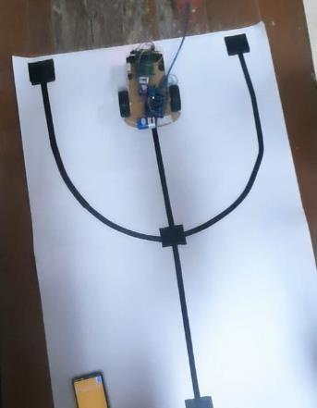

Figure 5.3.2 Bot movement to room 2

It is observed that when “Room 3” command is given, the bot traverses the route as drawn on the chart for room 3 as shown in figure 5.3.3

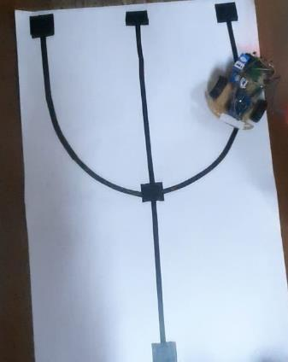

Figure 5.3.3 Bot movement to room 3

Thus, we have designed a robot prototype that delivers medicines to quarantined rooms using Arduino Uno and IR sensors. It receives the commands given to the App through Bluetooth module.

**REFERENCES**

1. Aditya Chaudhry, Manas Batra, Prakhar Gupta, Sahil Lamba, Suyash Gupta ‘ARDUINO BASED VOICE CONTROLLED ROBOT’ in 2019 International Conference on Computing, Communication, and Intelligent Systems (ICCCIS)
2. Non-Contact Medicine Dispensing System for Patients in Quarantine: Ms. Nanditha Krishna, Ms. R Navya Sree, Ms. Rajeshwari Sajith, Mr. S Kosal Ramji, Ms. Sheetal Ramesh in 2021 6th International Conference on Recent Trends on Electronics, Information, Communication & Technology (RTEICT), August 27th & 28th 2021